SOP BIKIN MONITORING CLUSTER POSTGRES DI GRAFANA

- Bikin connection di grafana
Home > Connections > Your connections > Data sources
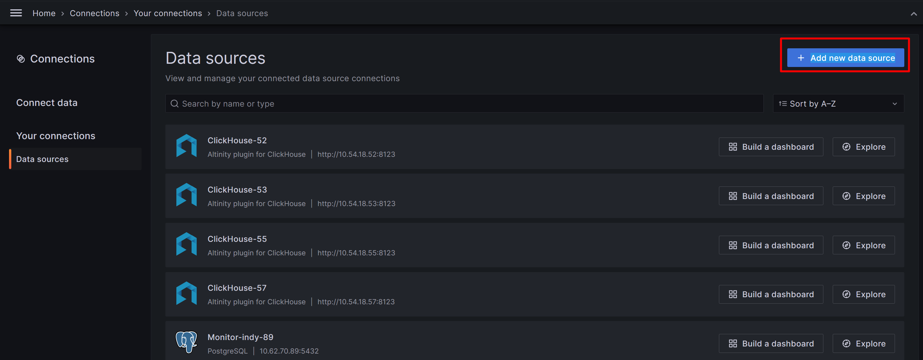
Add new data source

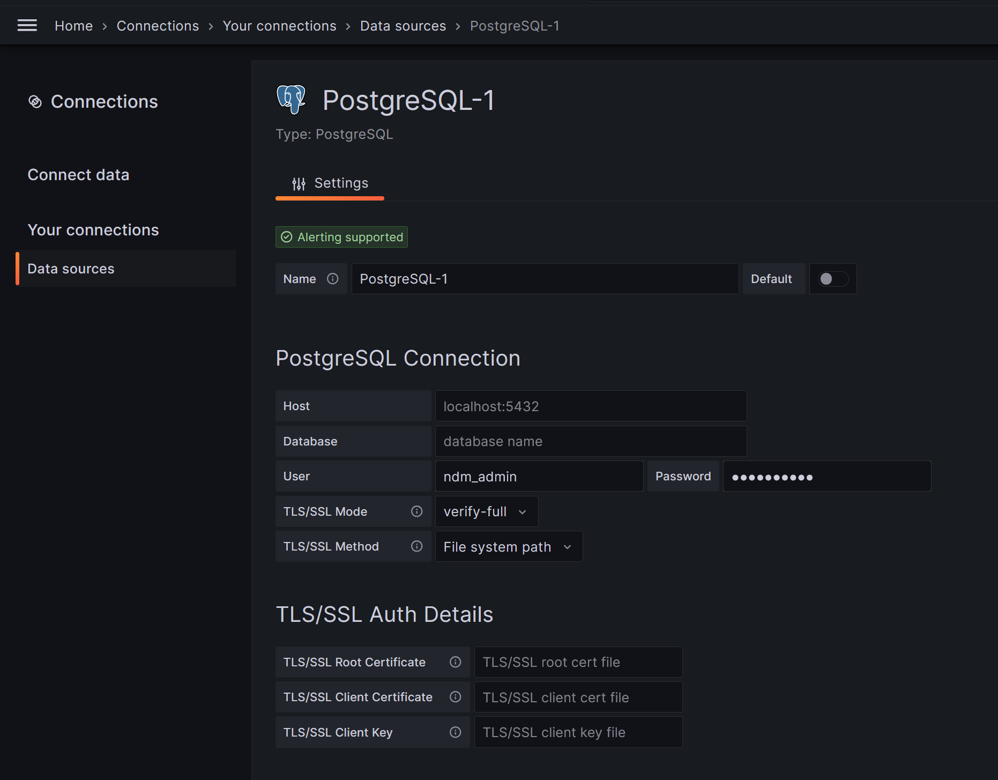
Isi sesuai data server
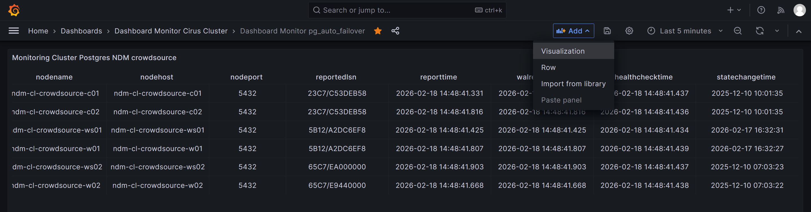

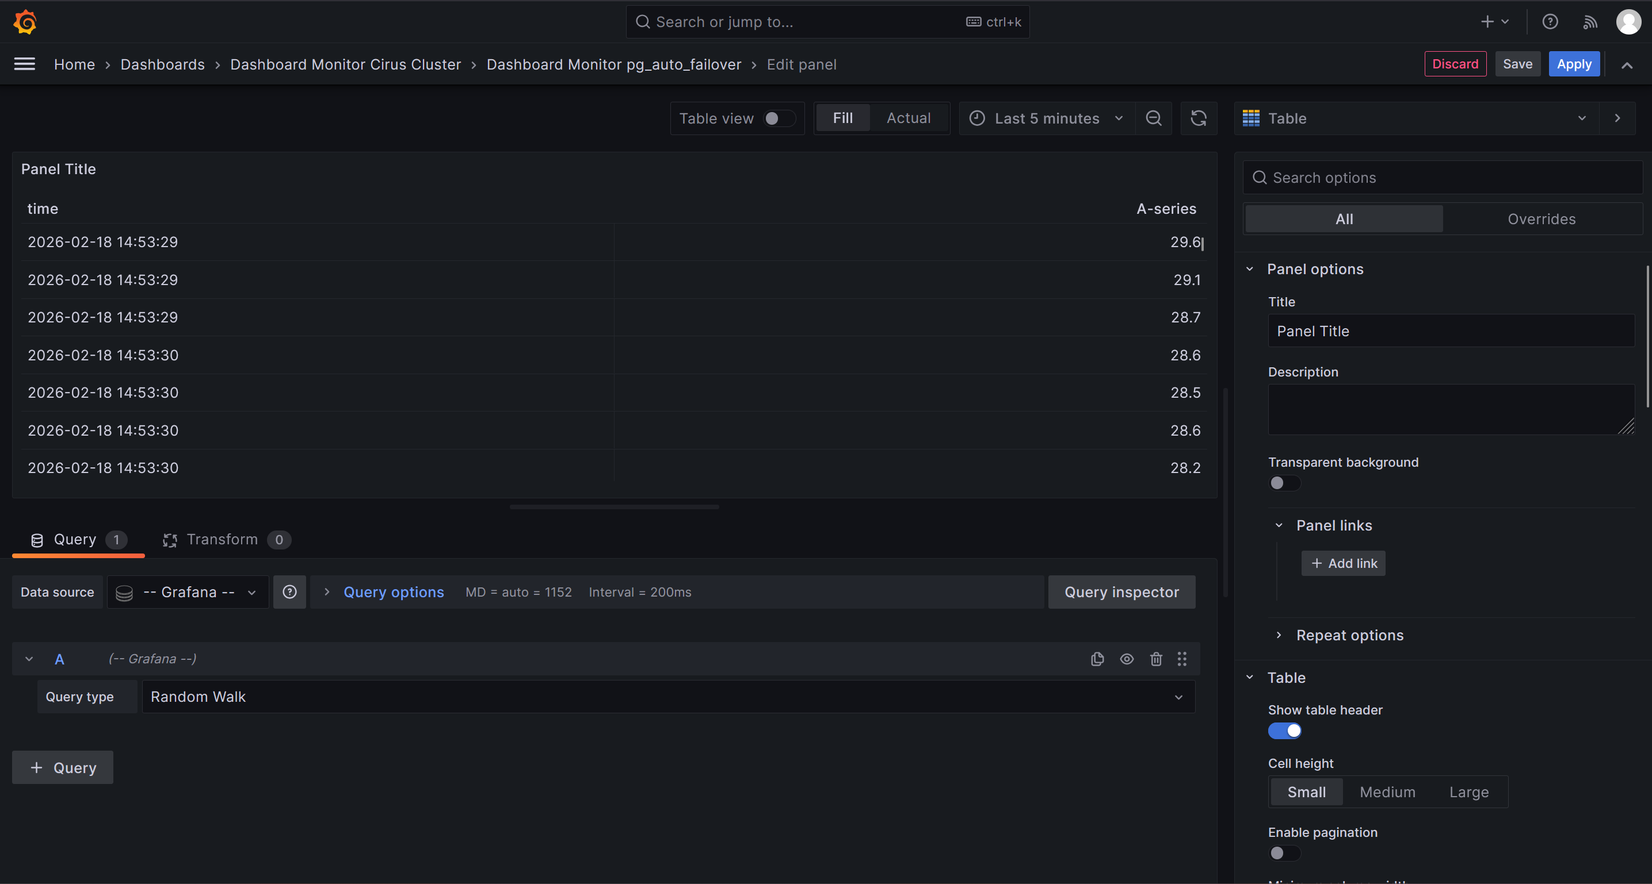
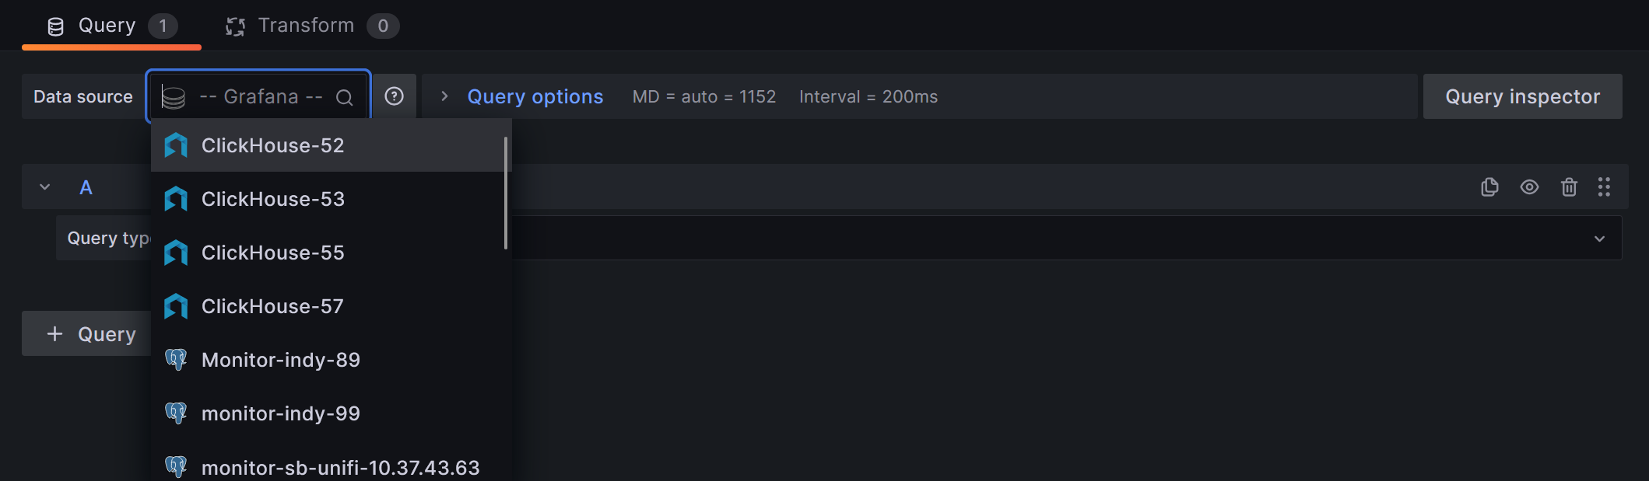
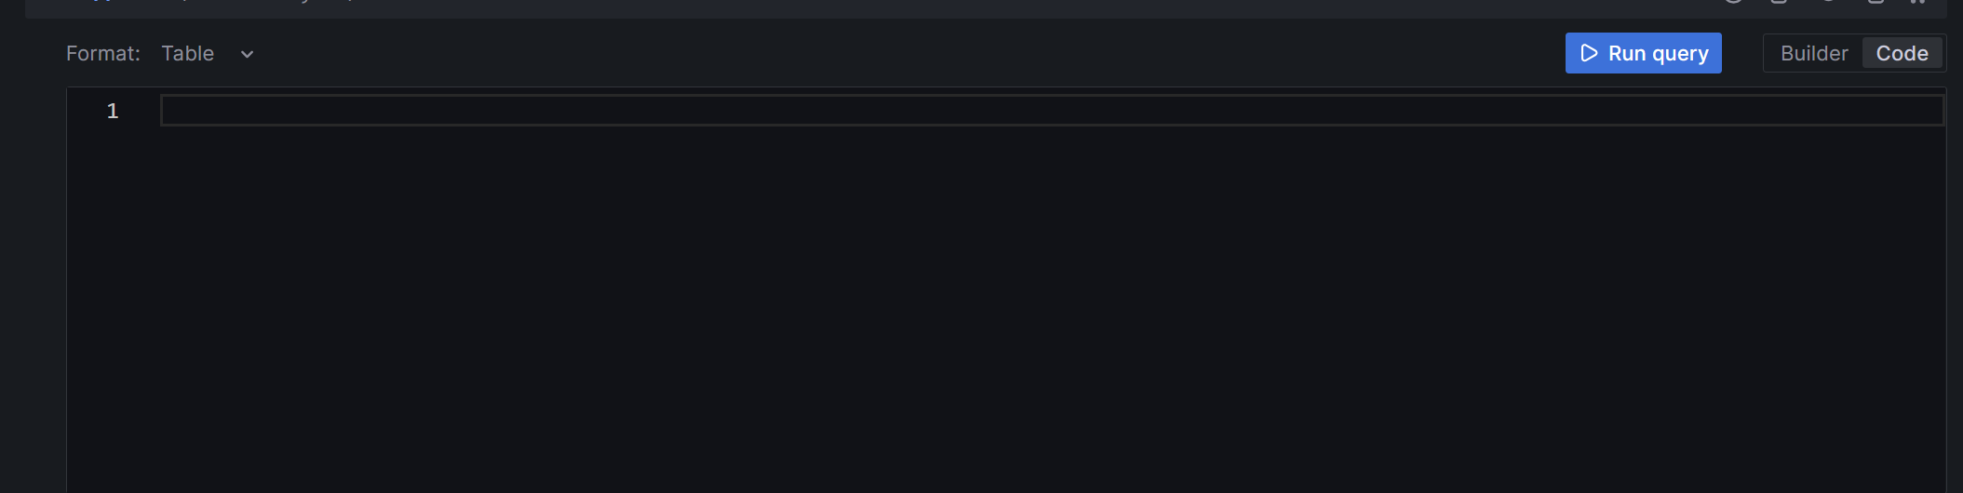
Query :
SELECT nodeid, groupid, nodename, nodehost, nodeport, reportedlsn, reporttime, walreporttime, healthchecktime, statechangetime, goalstate, reportedstate, health FROM pgautofailover.node ORDER BY groupid;

